**STUDY AND CREATION OF THE OFDM WIMAX SCHEME**

**2.2 Background**

**2.2.1 Scheme Nature**

Orthogonal Frequency Division Multiplexing is a communication wirelessly system that transmits data effectively and reliably across long distances in the 2 to 11 GHz frequency range. The OFDM technique used in WiMAX segments the data stream into many subcarriers, each of which conveys a smaller fraction of the total. By using multiple antennas at both ends of a WiMAX connection, signal quality is enhanced and fading is mitigated. Therefore, WiMAX's improved spectral efficiency and greater data throughput make it an ideal technology for delivering broadband internet access, multimedia services, and other high-bandwidth applications. Due to its flexibility and efficiency, the OFDM WiMAX system has become an integral part of the evolution of wireless communication standards.

The scheme was for creating the system of OFDM system. The system was initiated by collecting information between various systems such as OFDM and terms linked to it. Then, components like a data generator, randomizer, modulator, demodulator, etc were adopted to perform and create the overall proposed scheme. Then, the circuit connection of such a system was completed properly with the utilization of the selected elements in addition to the MATLAB workbench. The simulation of the suggested OFDM was done by preferring the relevant parameters and then the BER result was observed based on the graphical plot and concluded the project as well.

**2.2.2 Scheme Purpose**

The core purpose of the scheme development was to create the system of OFDM WiMAX system to perform channel equalization. There were a few other kinds of goals:

* To improve the quality of the communication signal by reducing BER.
* To increase the WiMAX system's based on the OFDM system's speed of transmission.

**2.2.3 Scheme Activities Nature**

I investigated the operation of the OFDM extensively, as well as how it functioned in the context of communication networks. To construct and prepare the scheme circuit design, I chose to use various aspects. I decided to operate, design, and effectively simulate an OFDM-based WiMAX architecture using MATLAB. After choosing the proper components for the design part, I designed the WiMAX transmitter model and produced OFDM symbols. I and my scheme mates created the WiMAX receiver system, end-to-end WiMAX system, subsystem model for channel estimation, and LMS subsystem model. I ran the simulation and watched the results as BER and SNR performance varied based on the different conditions.

**2.2.5 Duties**

* To read various resources and become familiar with the OFDM system.
* To choose the required software as well as different elements for the task of project.
* To create the connection diagram of the WiMAX transmitter model and also the model creation of OFDM symbols.
* To develop the interconnection diagram of the WiMAX receiver system in MATLAB
* To prepare the model of the WiMAX system of end-to-end type using MATLAB tools.
* To generate the subsystem model of channel estimation along with the LMS subsystem.
* To perform the simulation and observe the outcomes performance of BER and SNR.

**2.3 PEAs**

**2.3.1**

I researched the working of the OFDM and also studied how it operated in the field of communication networks. I educated myself about the WiMAX system and also read the operational mechanism of such a system by preferring the relevant websites. I preferred articles, and research papers to collect ideas about channel estimation along with equalization in a proper manner. I explored the Doppler effect and how it affected the system in a precise manner. I gathered information about the PN sequence generator and its working and applications. To learn about the convolutional encoder and decoder, I preferred the desired reports and magazines. I reviewed the QAM modulator baseband and its operational mechanism. I gained knowledge relevant to the randomizer and Viterbi decoder. I also studied the modulating and demodulating mechanism of the OFDM along with the OFDM receiver and transmitter. I explored the MATLAB tool with its function of designing and simulating the connection.

**2.3.2**

Then, I opted to employ the different elements for the task. For generating the PN sequence, I preferred to select the PN sequence generator and employed the logical operator to perform the logical types of operations. To obtain the integer from the bit format and bit from the integer format, I nominated the Bit to an integer. To select the given signals for the operation, I adopted the selector. I also picked out the convolutional encoder along with the decoder to perform the forward error correction by encoding the input data and vice-versa using the convolutional codes. I rearranged the data and mitigated the impact of these data during transmission by selecting the general block interleave. I also opted to use the de-randomizer to reverse the randomization process and to restore the original data and also selected the Viterbi decoder and encoder to use the Viterbi algorithm for decoding and encoding the data to minimize transmission errors. I also picked AWGN as the channel for the system. For performing the modulation and demodulation processing of the various signals, I preferred to select the modulator as well as demodulation. I chose MATLAB to operate the create as well as simulate OFDM-based WiMAX scheme properly and effectively.

**2.3.3**

I created the WiMAX transmitter model after selecting the appropriate components for the design section. For this, I fed the data source as well as the generator of the PN sequence along with the data source from the subsystem to the logical operator to perform the logical operations. I connected the logical operator to the buffer. Then, I converted the obtained bit into an integer by linking the bit to an integer converting scheme and fed it to the RS encoder to encode via buffer1. I linked encoder to the selector to select the signals & fed it to the integer-to-bit converter to obtain the bit signals. I fed the output from this converter to the convolutional encoder which was joined with the puncture and fed to the general block inter leaver. Then, I fed the output from this inter leaver to the bit-to-integer converter1 which was connected to the QAM modulator to modulate the obtained signals and linked to the OFDM-symbol block and obtained the sink data. I also prepared the system that represents the OFDM symbol.

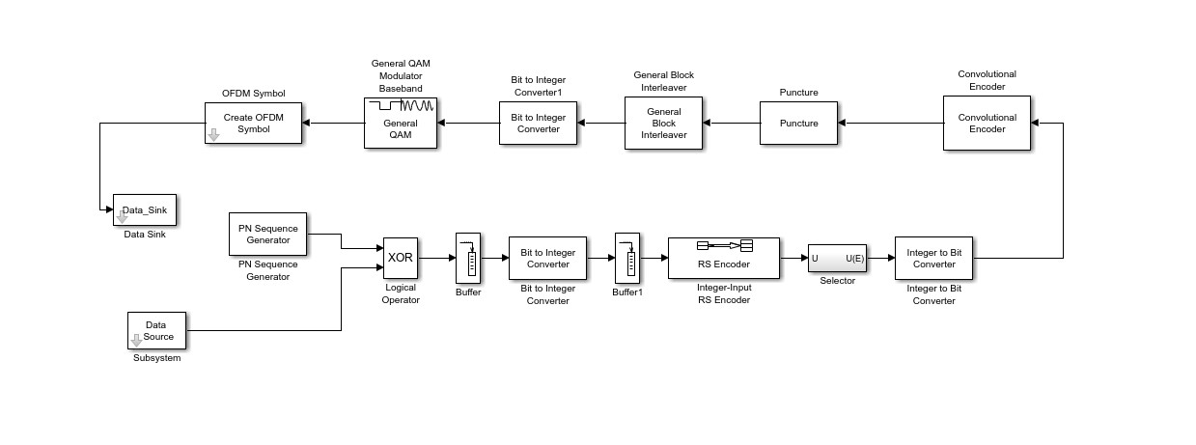

Figure 2: Model representing the Transmitter of WiMAX

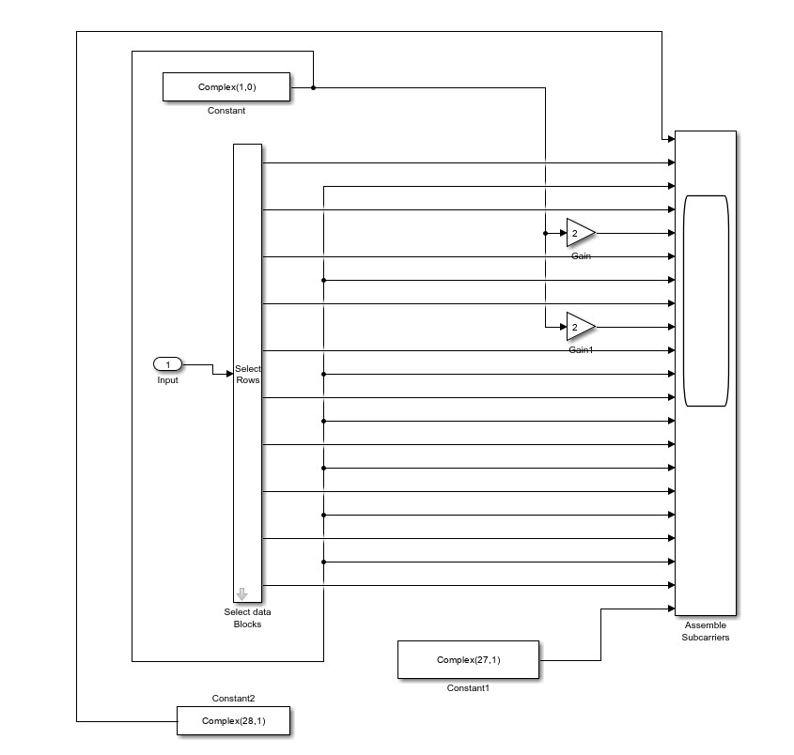

Figure 3: OFDM symbol model

**2.3.4**

Then, I created the WiMAX receiver system using the MATLAB workbench. For this, I placed the channel and linked it to the OFDM system whereas I linked the transmitter output to the unit delay block and linked output from both delay and OFDM system to the LS/LMS est system and fed to the conv to amplify the signal. Then, I linked the output signals to the channel interpolation and fed them to the product block along with the data from the OFDM and linked them to the demodulator. I joined the output from the demodulator to the deinterleaver and fed it to the Viterbi decoder. Furthermore, I joined this decoder to block the decoder and finally attached it to the de-randomizer. Then, I joined the de-randomizer to the o/p block.

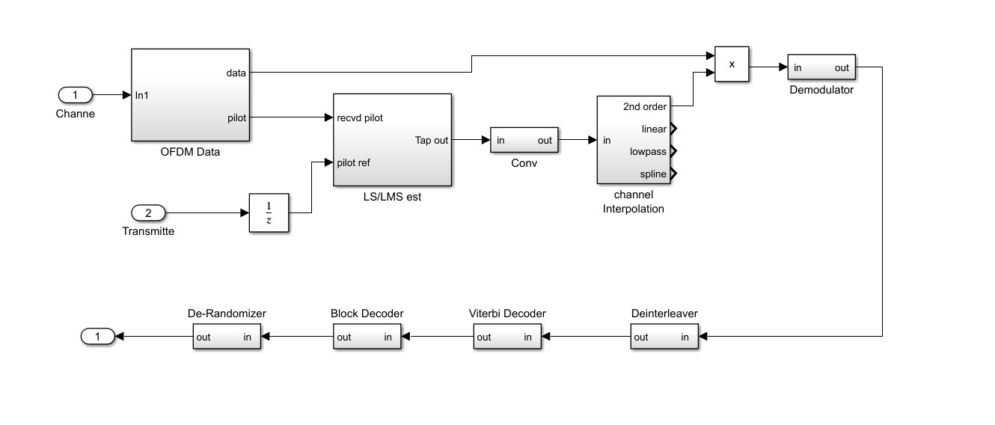

Figure 4: WiMAX receiver system

**2.3.5**

In this section, I designed the WiMAX system of end-to-end type by linking the generated data from the generator to the randomizer whose output was linked to the block encoder to encode the signal. I joined the outcome from the block encoder to the convolutional encoder and fed it to the interleaved. I joined the output from the interleaved to the modulator to modulate the signal along with then connected it to the OFDM symbol block whose output was attached to the channel model. I also attached the output of the channel to the OFDM data and fed this to the channel interpolation with and without the attachment of the channel estimation system. Then, I joined the outcome of the interpolation system to the demodulator to and then joined the deinterleaved. I linked the output of this to the Viterbi decoder to decode the signal and link to the decoder followed by the de-randomizer. I coupled the obtained signal from the de-randomizer to the calculator to determine the error rate in addition to the original data from the generator and showed the obtained output in the display device.

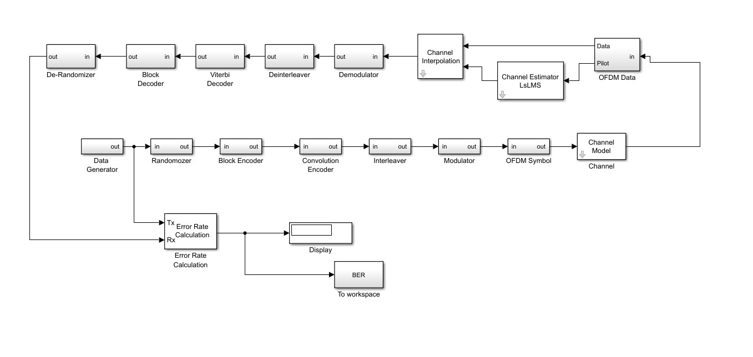

Figure 5: WiMAX system of end-to-end type

**2.3.6**

I created the subsystem model of channel estimation with MATLAB. As an i/p, I joined the input block to the four different MATLAB functions such as spline, lowpass, linear interp, and 2nd order interp. Then, I attached the four different MATLAB functions to another four different MATLAB functions respectively. I joined the MYIs1 to output1 and MYIs to output. I also linked the port_select1 to the MYIs3 and output3 and then the port_select to MYIs2 and output2. After that, I generated the model of the LMS subsystem. I attached the input to the select rows and joined them to the various LMS blocks. I coupled the LMS blocks, and input1 to the different subsystems. Then, I attached the subsystems to the Mux and linked them to the output block. I utilized the AWGN channel model, where the main communication hindrance is the insertion of wideband noise with a constant spectral density.

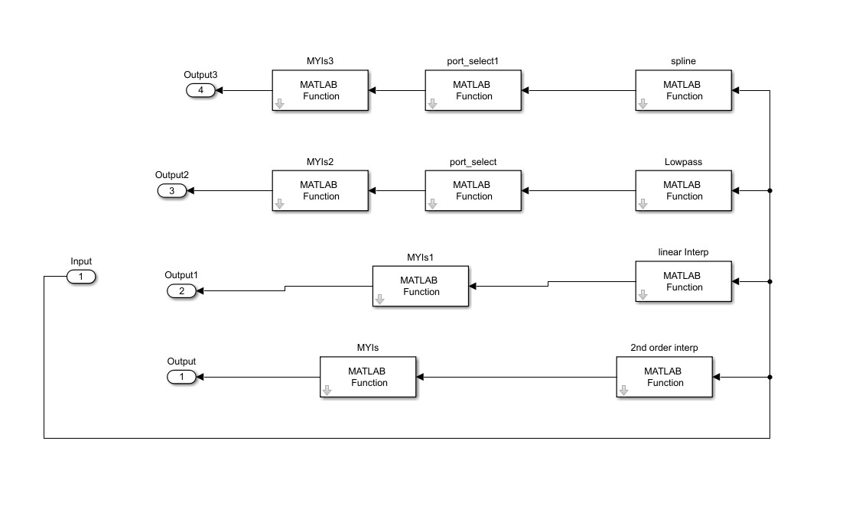

Figure 6: Channel estimation system

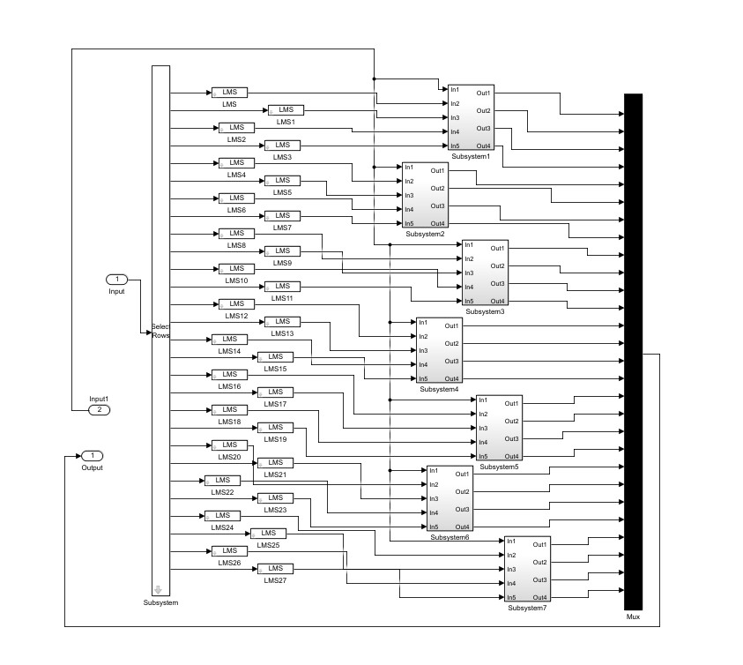

Figure 7: Model of LMS subsystem

**2.3.7**

I also utilized the AWGN channel along with Doppler shift and multipath for evaluating the system properly. I noticed the results for Lin Intetrp, 2nd Interp, spline, and lowpass graph between BER against SNR for LS interpolation and found the same nature of the graph with identical values which fall from 0 to 24 dB. I noticed that from LMS interpolation BER decreased from above 0.8 to E-4 dB. Then, I observed the resulting graph with a small Doppler shift with LS and found that the higher BER obtained in Lin Intetrp was 0.5 and the lowest BER of 0.3 was found in Lowpass. I noted the result with a small Doppler shift with LMS and found that the higher BER was obtained in Lin Intetrp of 0.5 and the lowest BER was found in the spline of 4. By creating the BER against SNR with a greater Doppler shift using LS, I looked at the resulting graph and discovered that Lin Intetrp had the biggest BER of 0.5 while Lowpass had the smallest of 0.2. With a greater Doppler shift using LMS, I discovered that the highest BER was obtained in Lin Intetrp and the lowest BER was found in Lowpass. I found that, before to Doppler shift, the low-complexity LS approach performs roughly the same for SNR as the more complex LMS estimator, but it behaved differently afterward. I concluded that the Doppler shift had a more significant influence on the relative efficacy of the various channel estimators as well as interpolation techniques.

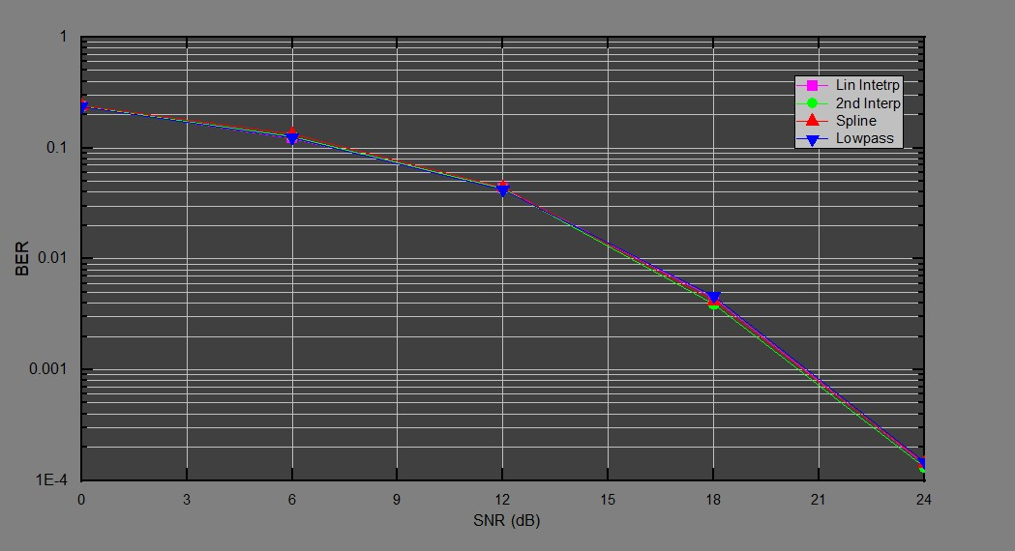

Figure 8: Graph of dB for LS under fixed circumstances and varied interpolation criteria

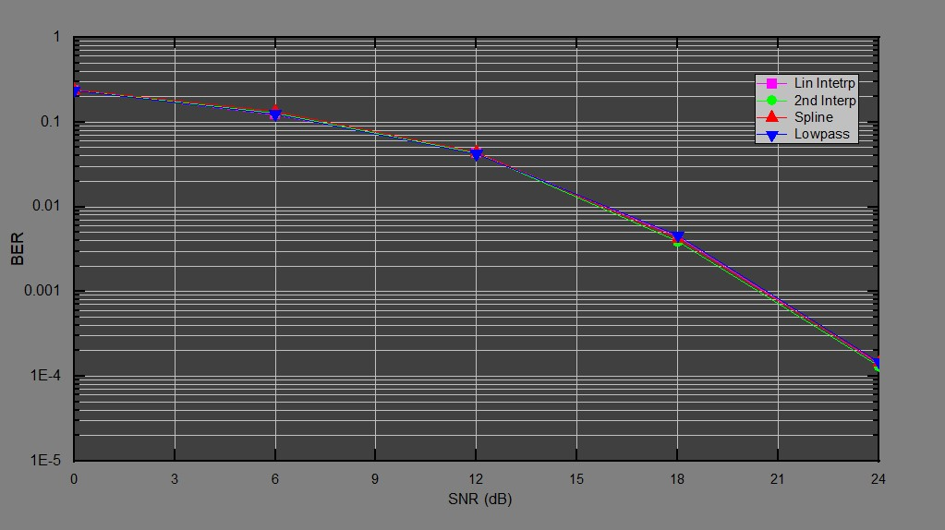

Figure 9: Graph of dB for LMS under fixed circumstances and varied interpolation criteria

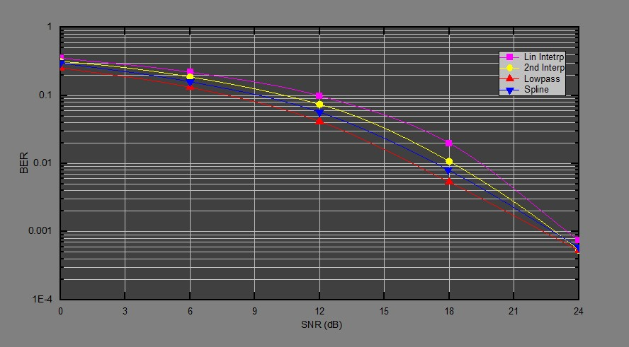

Figure 10: Graph of dB for LS for low relative velocities and slight Doppler shift

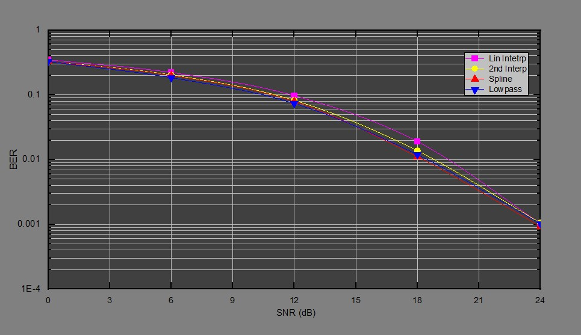

Figure 11: Graph of dB for LMS for low relative velocities and slight Doppler shift

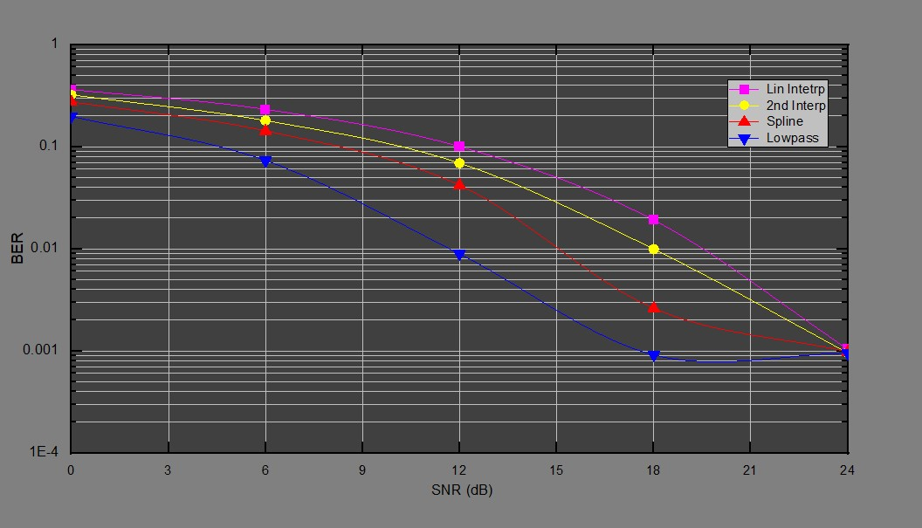

Figure 12: Graph of dB for LS for high relative velocities and high Doppler shift

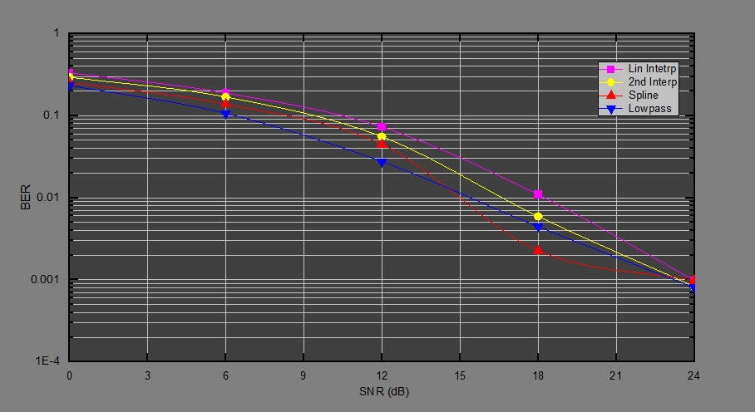

Figure 13: DB plot for LMS

**2.4 Difficulties & Mitigations**

After analyzing the output that was produced as a result of my observations, I discovered that the issue lay within the system. I discovered that the use of Rician fading, which generates the most amount of noise, was the root cause of the issue that was being observed. I also saw the lowest level of BER with the application of Racian, and after that, I debated this matter with both my supervisor as well as also the members of my group. After then, I investigated this issue further by looking it up on various web resources, and as a result, I was advised to make use of the AWGN rather than the Racian fading technique. Following that, I proceeded to create the AWGN kind of channel and then re-ran the simulation one more. After that, I discovered that the utilization of AWGN resulted in a decreased amount of noise as well as an improved BER being seen as a direct consequence of this.

**2.5 Creative Tasks**

I applied the AWGN instead of Racian fading to enhance the BER and reduce the noise in the system. I also applied the modulator and demodulator to modulate and demodulate the desired signals in a precise manner. To reverse the randomization procedure and get back the original data, I utilized the de-randomizer.

**2.6 Team Management**

I held an assortment of discussions for talk and discussion to keep everyone informed about the development of this effort. I pushed myself to complete the task before it was due. To ensure the task's reliable and efficient progress, I reviewed its progress regularly and at appropriate times. To guarantee successful project advancement, I obtained advice from professionals who were familiar with similar projects in past times. When everything was finished, I wrote a review based on my suggestions and presented it to the department's head as well as the supervisor.

**2.7 Codes**

I exerted much effort to see that the University's rules were followed. I explored the IEEE 802.16 code to discover additional information related to the study of the WINWAX.

**2.8 Summary**

The development of the scheme, whose goal was to create an OFDM WiMAX system to conduct channel equalization, was finished. MATLAB was used to prepare the models and then simulate them. Both the WiMAX transmitter model's connection diagram and the model for creating OFDM symbols were built. The WiMAX receiver system's connectivity diagram along with the end-to-end WiMAX system model was created. Both the LMS subsystem model and the subsystem model for channel estimation were constructed. Additionally, the simulation procedure was carried out, and the performance of BER and SNR under various conditions was observed. It was discovered that the low-complexity LS method performed about the same for SNR before the Doppler shift as the more complex LMS estimator, but that it behaved differently after. It concluded that the effectiveness of the various channel estimators along with the approaches respective to interpolation was more significantly influenced by the Doppler shift.

I upgraded the subject of study and enhanced my communication and leadership abilities. Spending time in this position I developed time-management and problem-solving skills that would be useful for presenting. I got an improved understanding of the MATLAB application.